36.35: 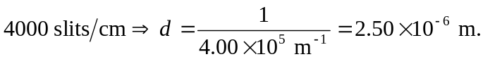 So for the hydrogen line, we have:
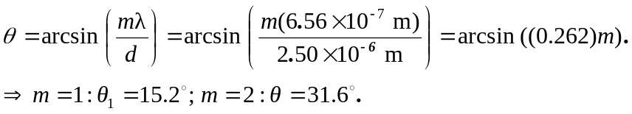
And for the 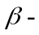hydrogen line, the angle is given by:
